**DATE AND TIME**

**Data Overview**

Central London

* **Original data set:** 1,048,366 entries.
* **Clean data set:** 758,163 entries (27.7% of rows containing no values were removed); no duplicates were identified.
* **Rows with missing dates in clean data set:** 10,156 (1.3% of all entries).

Due to inconsistency in date order no pattern was identified to fill the missing dates. The decision was made to leave it as NaT.

* **Errors in date classification:** 648 dates (0.09% of all dates) from ‘Survey date’ column were assigned to the wrong year in ‘Survey wave (calendar quarter)’ column and 25,698 dates (3.4% of all dates) from ‘Survey date’ column were assigned to the wrong quarter in ‘Survey wave (calendar quarter)’ column. The identified errors were amended.

Inner London

* **Original data set:** 615,168 entries.
* **Clean data set:** 508,707 entries (91,392 = 14.9% of rows containing no values were removed; and then 15,069 = 2.9% of rows (excluding rows with no values) were removed).
* **Rows with missing dates in clean data set:** 2,752 (0.5% of all entries).

Due to inconsistency in date order no pattern was identified to fill the missing dates. The decision was made to leave it as NaT.

* **Errors in date classification:** 384 dates (0.08% of all dates) from ‘Survey date’ column were assigned to the wrong year in ‘Survey wave (year)’ column. The identified errors were amended.

Outer London

* **Original data set:** 375,660 entries.
* **Clean data set:** 375,660 entries; no duplicates were identified.
* **Rows with missing dates in clean data set:** 1,168 (0.3% of all entries).

Due to inconsistency in date order no pattern was identified to fill the missing dates. The decision was made to leave it as NaT.

* **Errors in date classification:** none identified.

**Insights and observations**

Timeline related to COVID restrictions

(https://www.instituteforgovernment.org.uk/data-visualisation/timeline-coronavirus-lockdowns):



General

* The highest average number of cycle trips per 15mins (6AM-10PM) is recorded for Central London (16.65) followed by Inner (6.20) and Outer (1.59) London data sets. Possibly because the closer people live to the workplace, the more likely they will cycle OR because the cycle infrastructure is better/richer closer to Center London.

Central London

* **Dates included:** from 20-01-2014 to 30-12-2021.
* **No data for:**
* Q1: 2021;
* low number of entries in 2020 for Q2 and Q4;
* Saturday, Sunday: 2014-2020; low number of entries for 2021.
* Average number of cycles per 15 mins (6AM-10PM) were increasing from 2014 to 2019 (from 15.63 to 17.80); then has dropped in 2020 to 15.86 and increased to 16.35 in 2021. Possibly because lots of people who rented accommodations in Central London returned back to their regions/countries in 2020 and spent lockdowns with their families. With people returning back to work in 2021 the average number of cycle trips has increased.

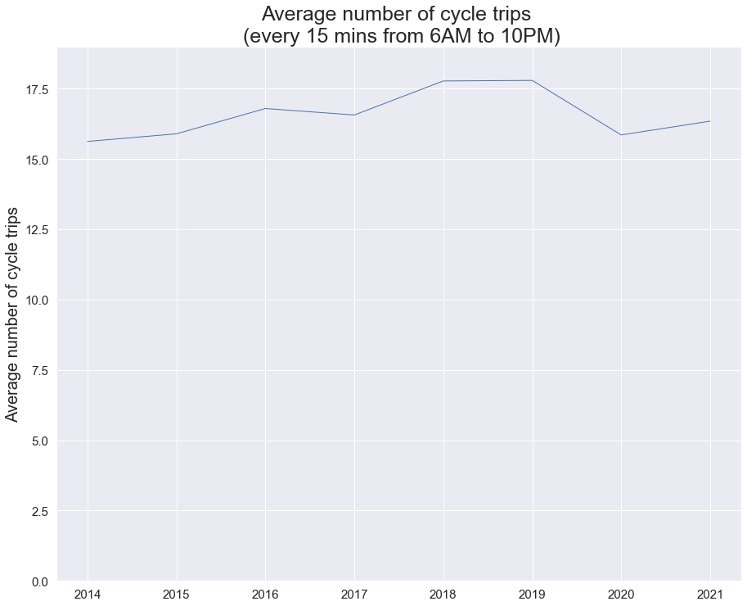

* Seasonality in number of cyclists on the roads were observed between 2014-2019 with the higher number of cyclists on the roads in Q2 (April-June) and Q3 (July-September) possibly due to better weather conditions.
* Due to some missing data, average number of cycle trips (every 15 mins between 6AM and 10PM) only for Q2-Q4s in 2017-2019 and 2021 were compared:
* 2017: before London Mayor's Transport Strategy (March 2018);
* 2018: pre-COVID pandemic;
* 2019: start of COVID pandemic but no lockdowns in London yet;
* 2021: no lockdowns in London from Q2 onwards.

An upward trend in average number of cycle trips was identified for April-October 2021, demonstrating recovery of cycle traffic after COVID pandemic; which has changed to the downward trend from October 2021 until December 2021 and closely followed 2019 pattern (possibly due to an increase in COVID cases from mid-September 2021 and spread of Omicron variable during Q4-2021).

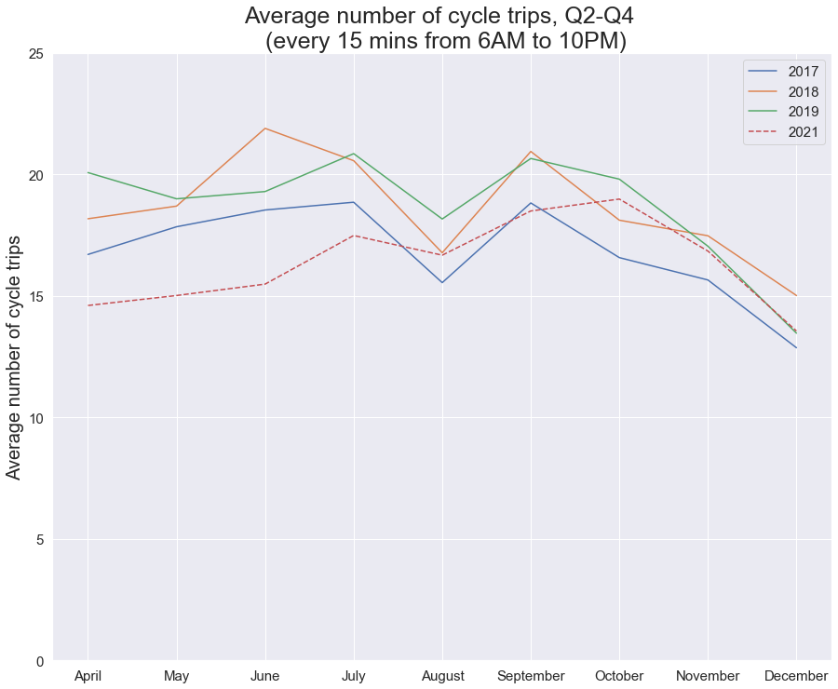

* Change in patterns related to the busiest time periods was observed in Q2-Q4 2021 with average number of cycling trips decreased during AM and PM peak hours (possibly due to some people working remotely or on hybrid basis) and increased during Inter-peak and Evening hours (possibly because people cycle more often for leisure).

Looking at data by 15 minutes time slots: consistent increase in number of cycle trips in Q2-Q4 2021 between 10AM and 5PM, and after 7:30PM vs Q2-Q4 2017-2019.

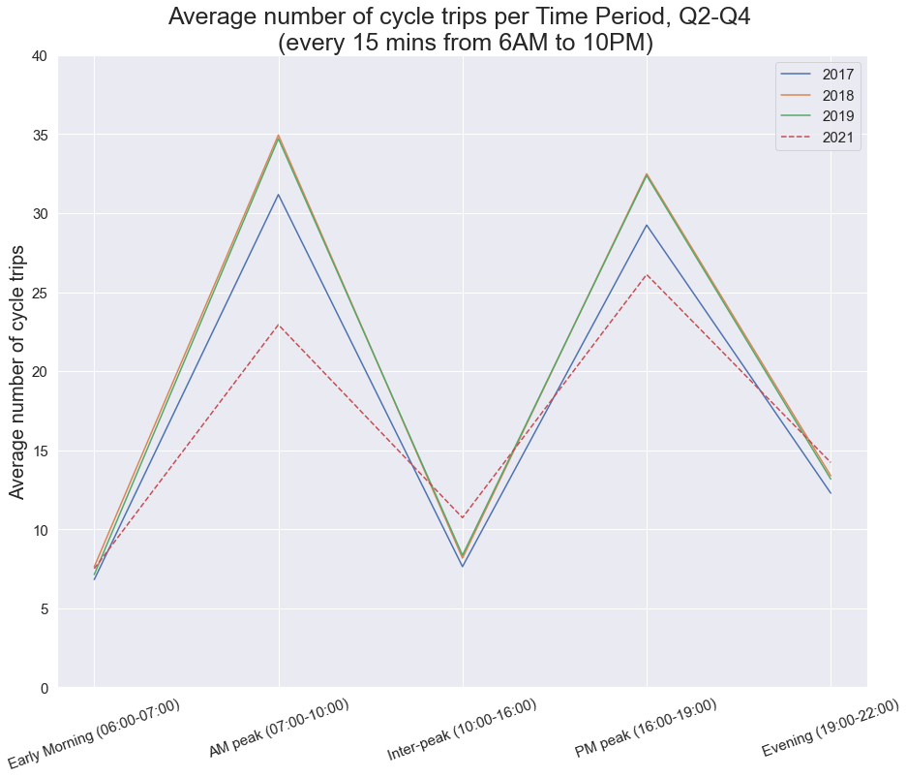

* Change related to the highest average number of cycle trips per weekday was observed in Q2-Q4 2021 with Monday becoming one of the quietest days of the week (possibly due to people who are working on hybrid basis come to the offices mainly between Tuesdays and Thursdays).

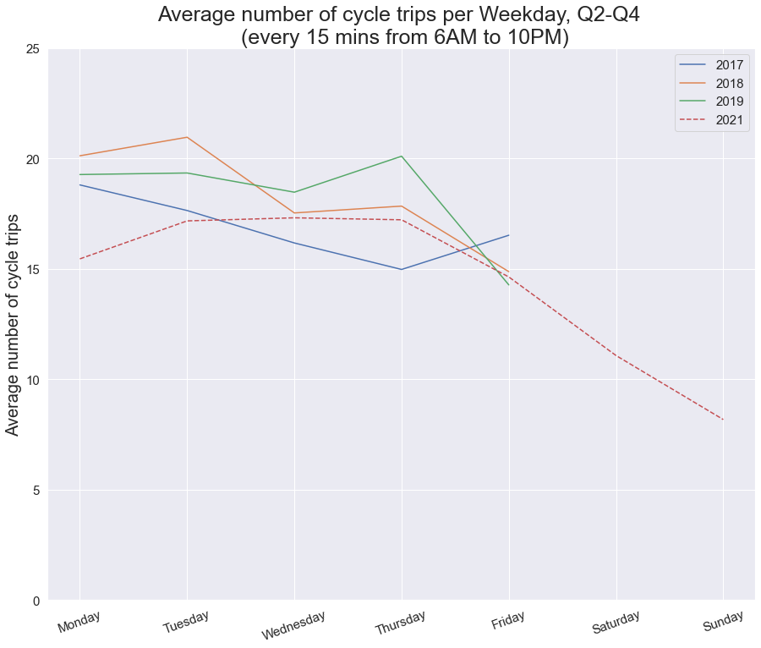

Inner London

* **Dates included:** from 13-04-2015 to 16-09-2021;
* **No data for:**
* Q1: 2015-2017, 2020-2021;
* Q2: 2020;
* Q4: 2015-2017, 2021;
* low number of entries in 2018 for Q1 and Q4;
* less number of entries for Q3 vs Q2 overall (Q3=23.0% of Q2+Q3);
* Saturday, Sunday: 2015-2017, 2020 (also no data for Saturdays in 2018); low number of entries for 2019 and 2021 (also low number of entries for Saturdays in 2018).
* Average number of cycle trips per 15 mins (6AM-10PM) were overall flat between 2015 and 2019 (5.89 and 5.86 respectively); then it has noticeably increased in 2020 to 8.54 and has dropped almost to 2019 levels in 2021 (6.24). Possible reasons: lockdowns and advise to work from home in Q3 and Q4-2020 (one form of exercise per day was allowed, per person - including cycling, while bike shops remained open); some people continued to work from home and on hybrid basis in 2021.

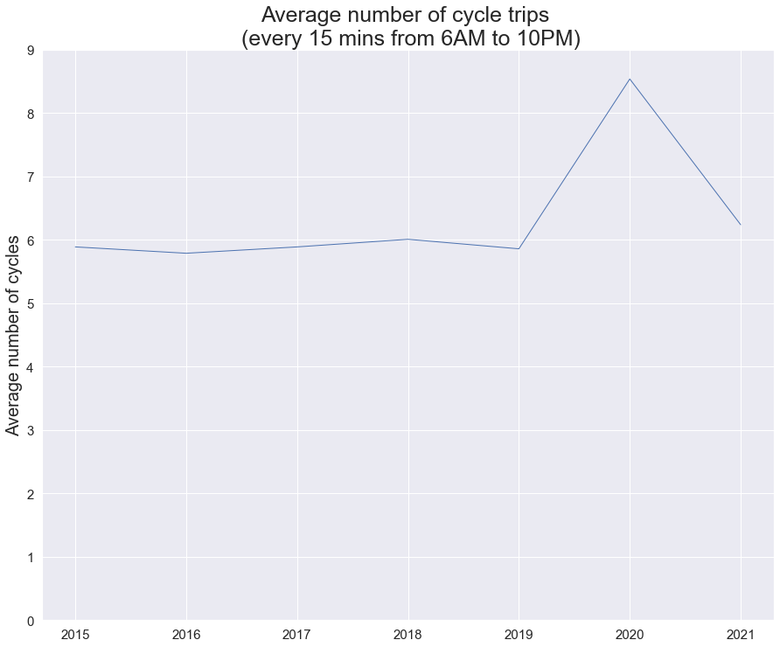

* It is not possible to explore the annual seasonal tends related to the number of cycle trips because the data is mainly present for April-July. Nevertheless, the below line plot shows that the average number of cycle trips in April 2021 was higher than in 2017-2019; in May 2021 it was similar to 2018 (higher than in 2017 and 2019) then it stayed flat until July 2021 when it was the lowest comparing to 2017-2019. No obvious reasons identified at this stage; but on 14th June 2021 the Prime Minister has announced the delays in Step 4 of the roadmap by four weeks, until 19 July, as the government accelerates the vaccination programme.

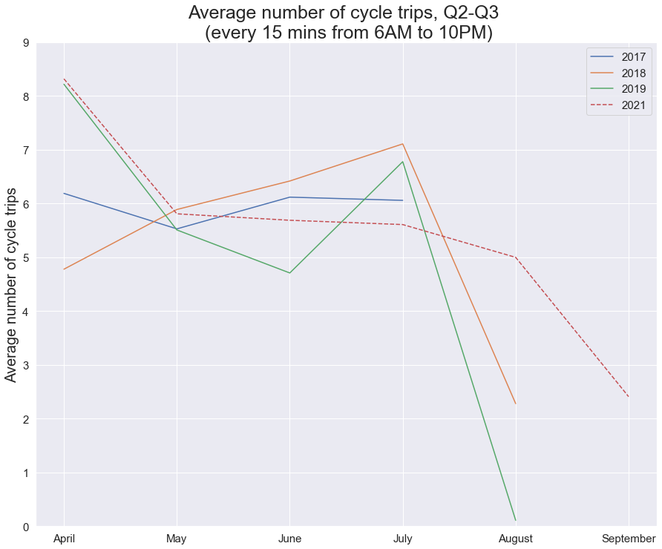

* Change in patterns related to the busiest time periods was observed in Q2-Q3 2021 with average number of cycling trips decreased during AM peak hours, stayed fairly flat in Q2-Q3 2019 during PM peak hours and increased during Inter-peak and Evening hours (possibly because people cycle more often for leisure).

Looking at data by 15 minutes time slots: consistent increase in average number of cycle trips between 9:30AM and 5:30PM, and after 7:00PM in Q2-Q3 2021 vs 2017-2019.

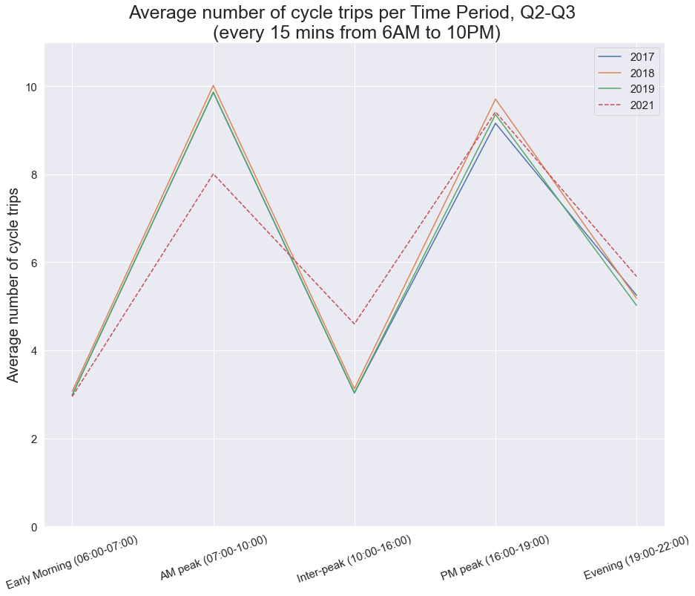

* In Q2-Q3 2021 the similar pattern to Q2-Q3 2019 was observed when the average number of cycle trips per weekday was the highest on Monday and the lowest on Friday. The average numbers of cycle trips on Tuesdays, Wednesdays and Thursdays were similar in Q2-Q3 2021; unlike in other investigated years when either upward (2017) or downward (2018-2019) trends during the mid-week period were observed. The average number of cycle trips per weekday was consistently higher in Q2-Q3 2021 vs 2019. It was challenging to investigate the weekend trends due to the low number of observations in the data set. Overall, the trend in 2021 is similar to 2019.

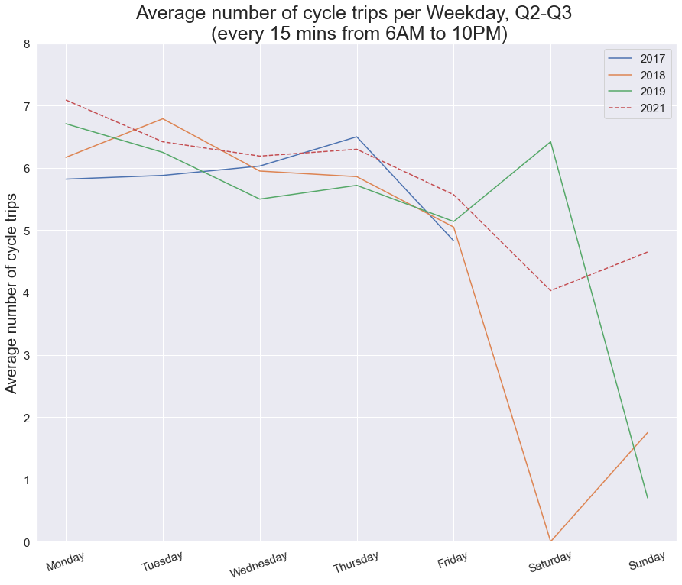

Outer London

* **Dates included:** from 13-04-2015 to 24-07-2021.
* **No data for**:
* Q1;
* Q2: 2020;
* Q4: 2015-2017, 2019, 2021;
* low number of entries for Q4-2018;
* less number of entries for Q3 vs Q2 overall (Q3=16.9% of Q2+Q3)
* Saturday, Sunday: 2015-2016, 2018-2020; low number of entries for 2017 and 2021.
* Average number of cycles per 15 mins (6AM-10PM) were overall flat between 2015 and 2019 (1.42 and 1.43 respectively); then it has noticeably increased in 2020 to 2.52 and has dropped in 2021 to 1.72. Possible reasons: lockdowns and advise to work from home in Q3 and Q4-2020 (one form of exercise per day was allowed, per person - including cycling, while bike shops were remain open); some people continued to work from home and on hybrid basis in 2021.

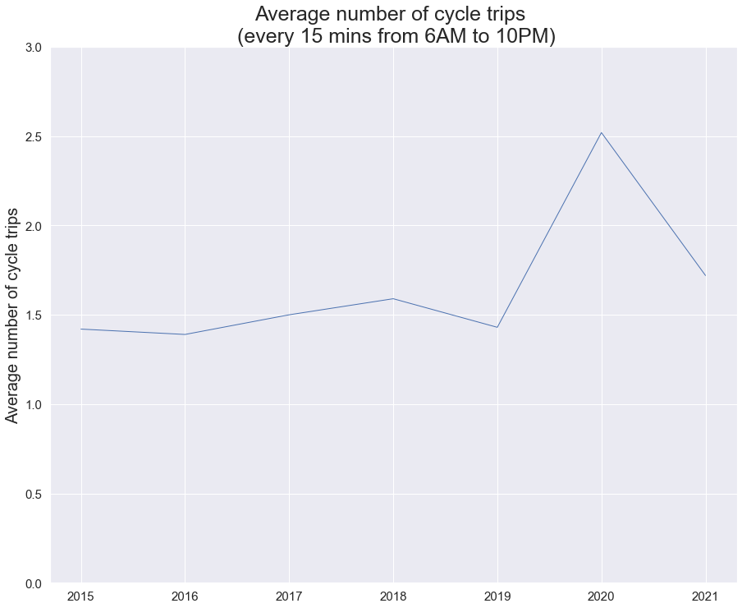

* It is not possible to explore the annual seasonal tends related to the number of cycle trips because the data is mainly present for April-July. Nevertheless, an upward trend between April and July 2021 was observed (similar to April-July 2017); during this period only in April 2021 the average number of cycle trips was below any another year (2018). No obvious reasons identified at this stage. Possibly because more people have relocated to Outer London.

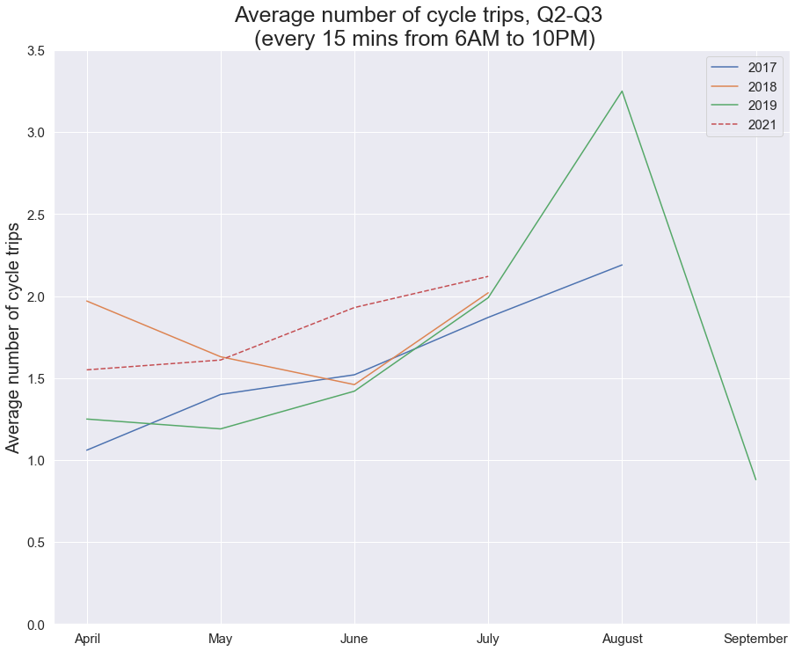

* In Q2-Q3 2021 similar to Q2-Q3 2018 patterns were observed which are related to the average cycle trips during Early Morning, AM and PM peaks, and Evenings whilst the average number of cycle trips during the Inter-peak hours was the highest in Q2-Q3 2021 (possibly because people cycle more often for leisure).

Looking at data by 15 minutes time slots: consistent increase in average number of cycle trips between 9:15AM and 5:00PM in Q2-Q3 2021 vs 2017-2019. With the peak of cycling traffic during the second half of the day changing from 6PM in Q2-Q3 2017-2019 to 5:30AM in Q2-Q3 2021.

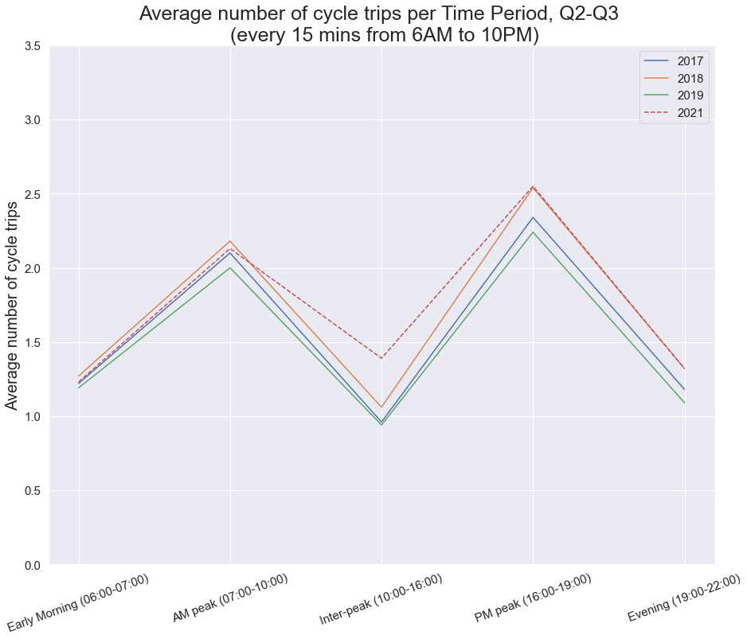

* Change related to the highest average number of cycle trips per weekday was observed in Q2-Q3 2021 with Monday becoming one of the quietest day of the week whilst Wednesday became the busiest day of the week in Q2-Q3 (possibly due to majority of people who are working on a hybrid basis work from home on Mondays) .

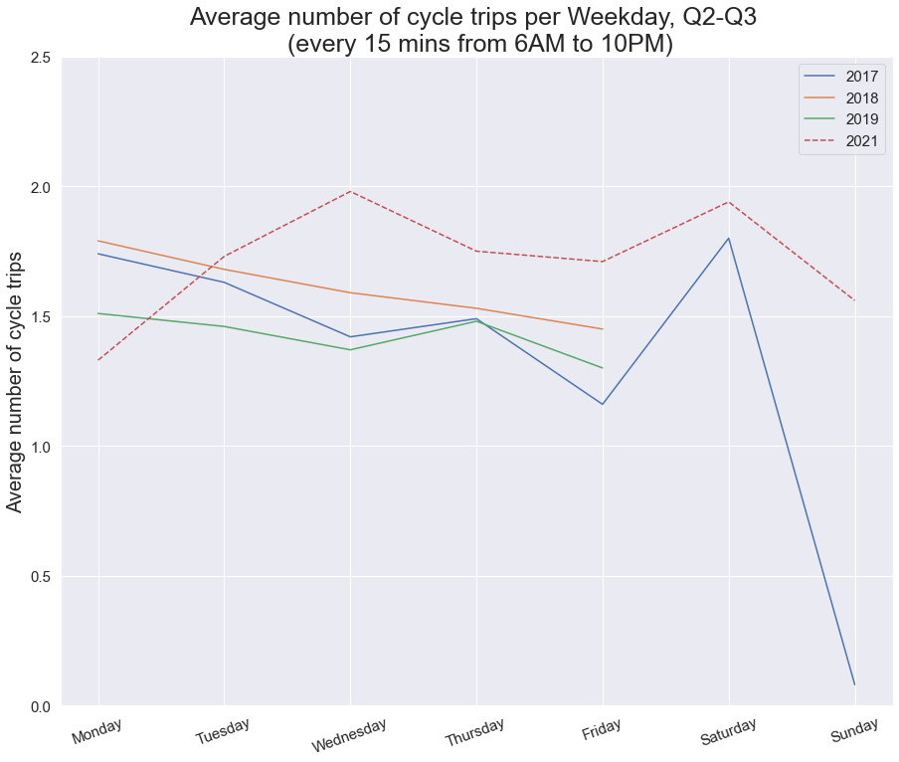

**HYPOTHESIS:**

1. Number of cycle trips depends on the population in the area (I’ve found some evidence).

Data:

* 2015-2020: Population of the UK by country of birth and nationality: individual country data (Office for National Statistics website – https://www.ons.gov.uk/peoplepopulationandcommunity/populationandmigration/internationalmigration/datasets/populationoftheunitedkingdombycountryofbirthandnationalityunderlyingdatasheets):

January 2015 to December 2015 edition;

January 2016 to December 2016 edition;

January 2017 to December 2017 edition;

January 2018 to December 2018 edition;

January 2019 to December 2019 edition;

January 2020 to December 2020 edition.

* 2021: Population and household estimates, England and Wales: Census 2021 (Office for National Statistics website – https://www.ons.gov.uk/peoplepopulationandcommunity/populationandmigration/populationestimates/datasets/populationandhouseholdestimatesenglandandwalescensus2021).
* Data in the above data sets is divided between Inner and Outer London. Therefore, the decision was made to combine data for Q2-Q3 2015-2021 from Central and Inner London data sets into one (Inner London data set) to have the most accurate representation of both data sets.
* Inner London:

Population in Inner London has dropped in 2021 below 2015 level, the average number of cycle trips (every 15 mins) in Q2-Q3 2021 has also dropped below Q2-Q3 2015 level.

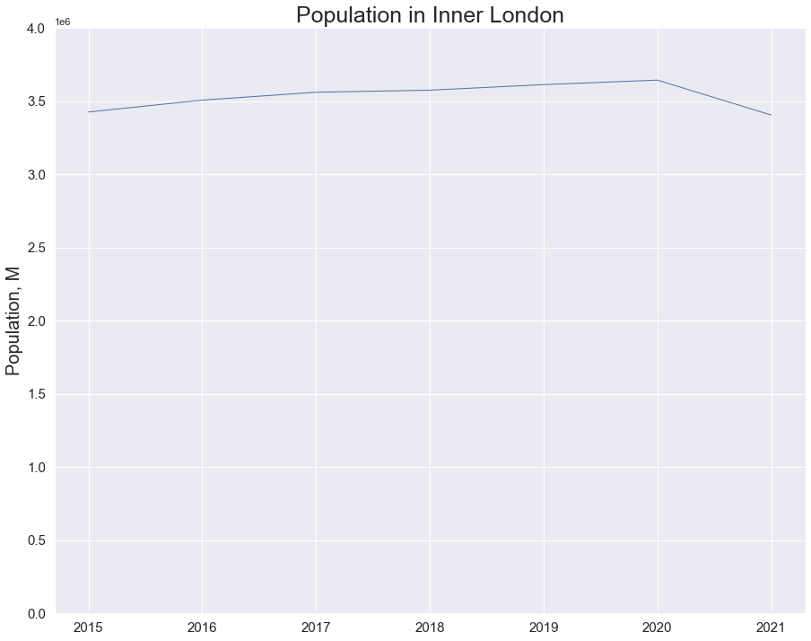

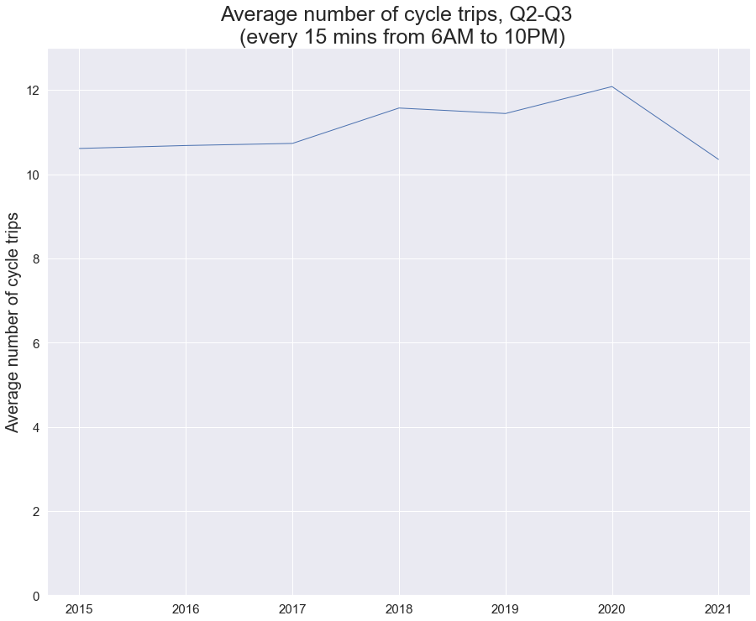

* Outer London:

Population in Outer London has decrease between 2020 and 2021 by 0.38%, the average number of cycle trips (every 15 mins) has decreased by 31.75% (possibly because of the better cycle infrastructure).

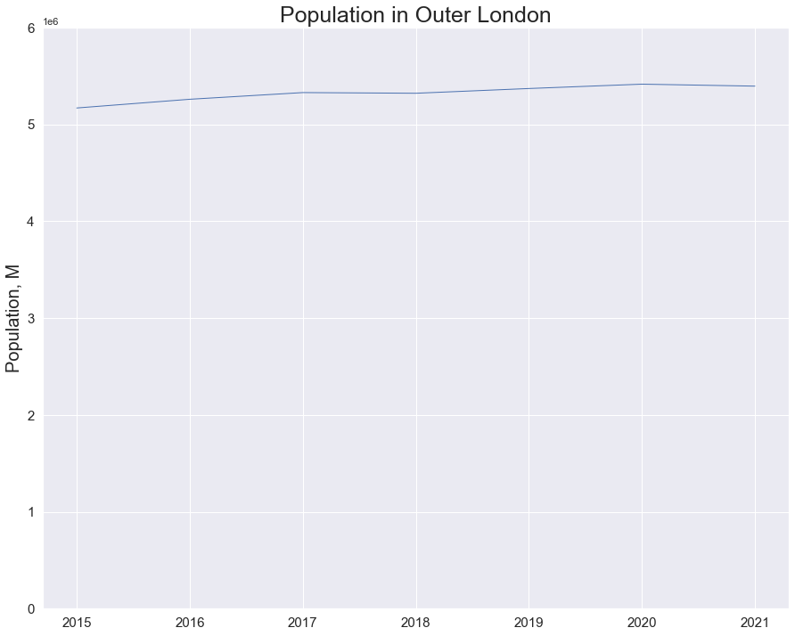

1. Highest number of average cycle trips were observed in all three data sets during AM and PM peak hours. It was suggested that Londoners mainly cycle to/from work. Therefore, the average number of cycle trips might decrease if more people work from home/hybrid basis (found evidence of the opposite but very limited data and cannot compare results for 2019-2020 and 2021).

Data:

* 2019-2020: Homeworking in the UK labour market (Office for National Statistics website – https://www.ons.gov.uk/employmentandlabourmarket/peopleinwork/employmentandemployeetypes/datasets/homeworkingintheuklabourmarket);
* 2021: Method used to travel to work Survey (Office for National Statistics website – https://www.ons.gov.uk/datasets/TS061/editions/2021/versions/2).
* Data in the above data sets were grouped into Inner and Outer London categories in line with classification used in hypothesis 1.
* Proportion of Londoners who work mainly at or from home has changed between 2019 and 2020 (IL/OL 2019: 40/60; 2020: 44/56); the trend has continued in 2021 (48/52).
* In March 2021 63% of all Londoners who had to travel to work and used bicycle were from Inner London.
* Inner London:
* Number of people who work mainly at or from home has increased in 2020 vs 2019 by 46.88%; average number of cycle trips in Q2-Q3 2020 has increased by 5.59% vs the same period in 2019;
* 9.02% of respondents who said in March 2021 that travel to work used bicycles.
* Outer London:
* Number of people who work mainly at or from home has increased on 2020 vs 2019 by 22.65%; average number of cycle trips in Q2-Q3 2020 has increased by 76.22% vs the same period in 2019;
* 2.93% of respondents who said in March 2021 that travel to work used bicycles.

1. Londoners cycle for non-work/leisure related reasons more often in 2021 than in 2015-2019 (I was trying to find data related to number of restaurants/bar on London streets but did not find anything later than 2017 and decided not to use it. Below findings is the best what I managed to find).

Data:

* March 2022: London at night: research and analysis (https://www.data.gov.uk/dataset/ebef45bf-84b4-4060-9c86-72bca0b18048/london-at-night-research-and-analysis):

This survey explored the behaviours and experiences of 2000 Londoners 48% Males and 52% Females) at night, though the focus of the survey was on night time work. ‘Night’ or ‘Night time’ refers to anytime between 6PM and 6AM.

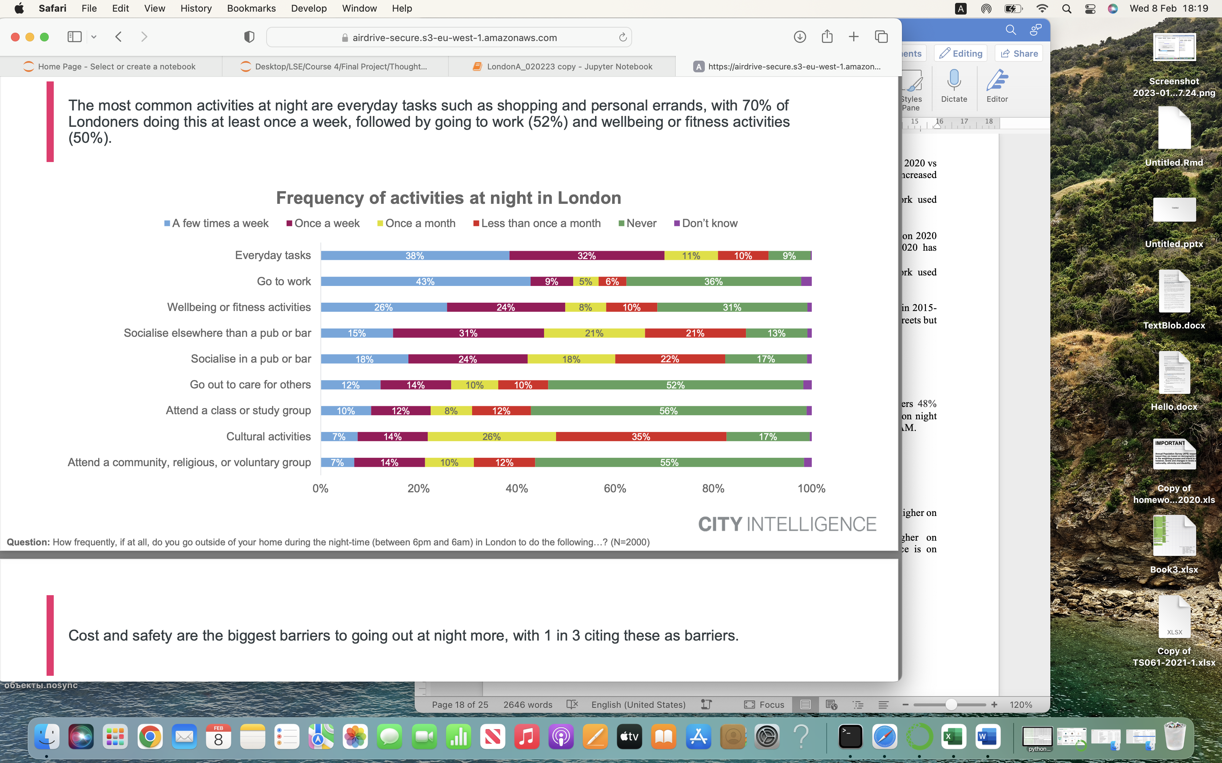

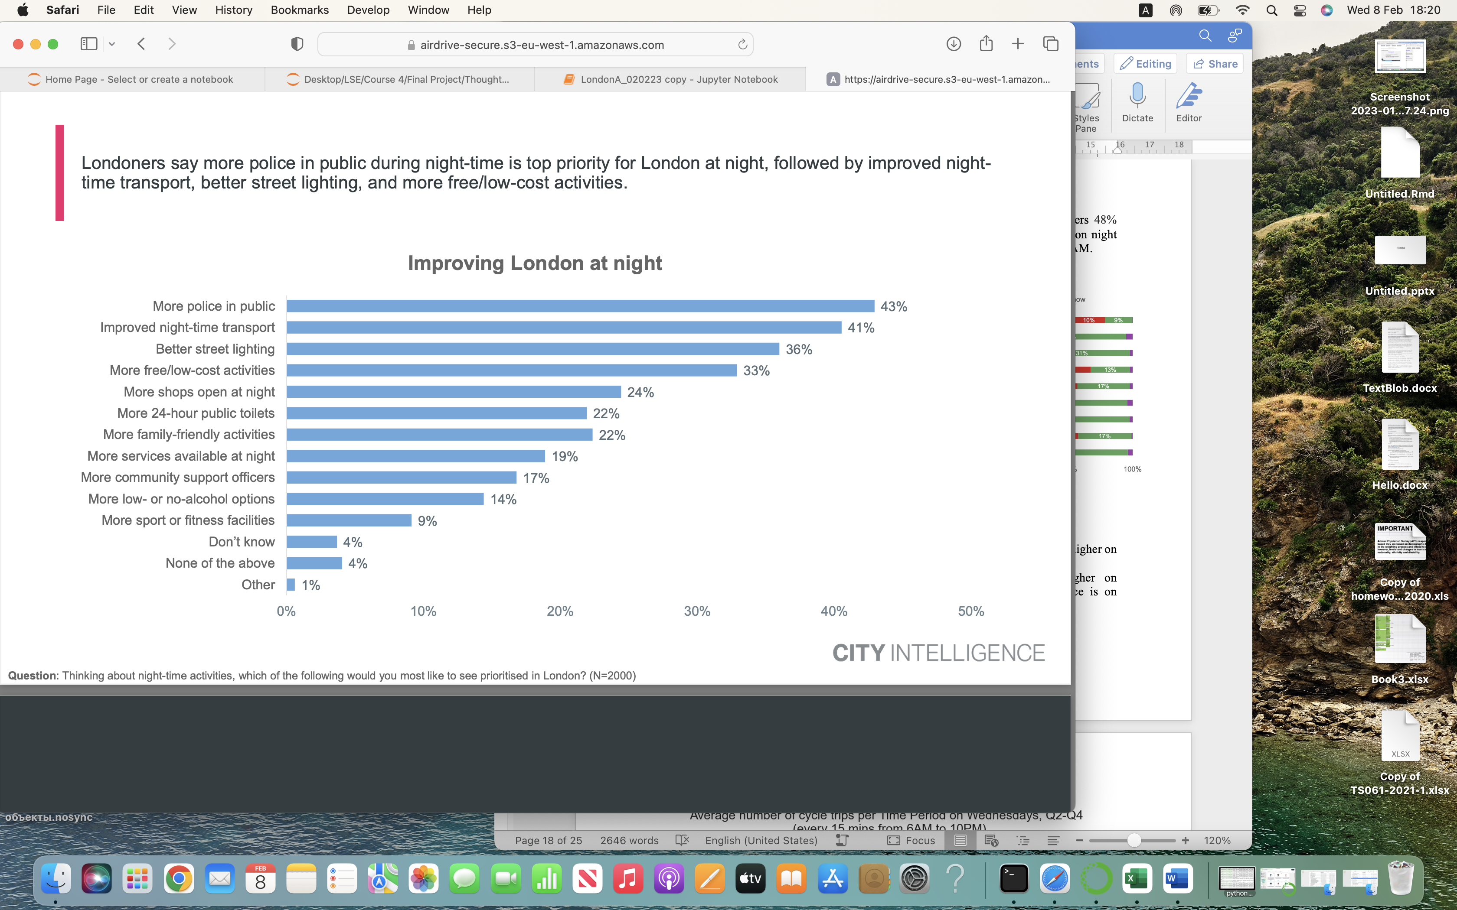

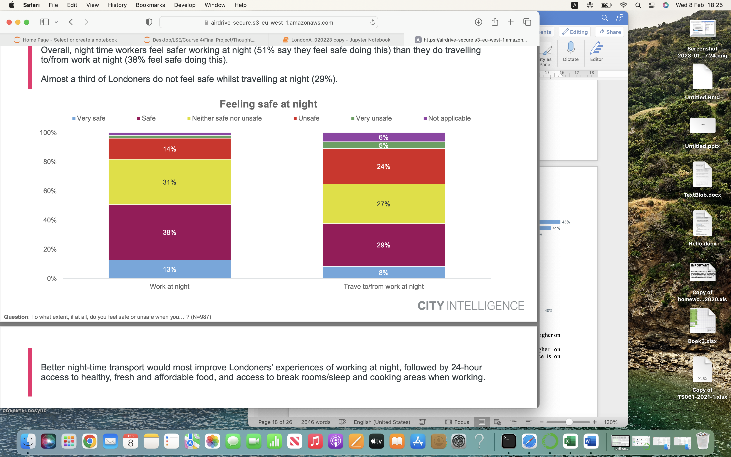

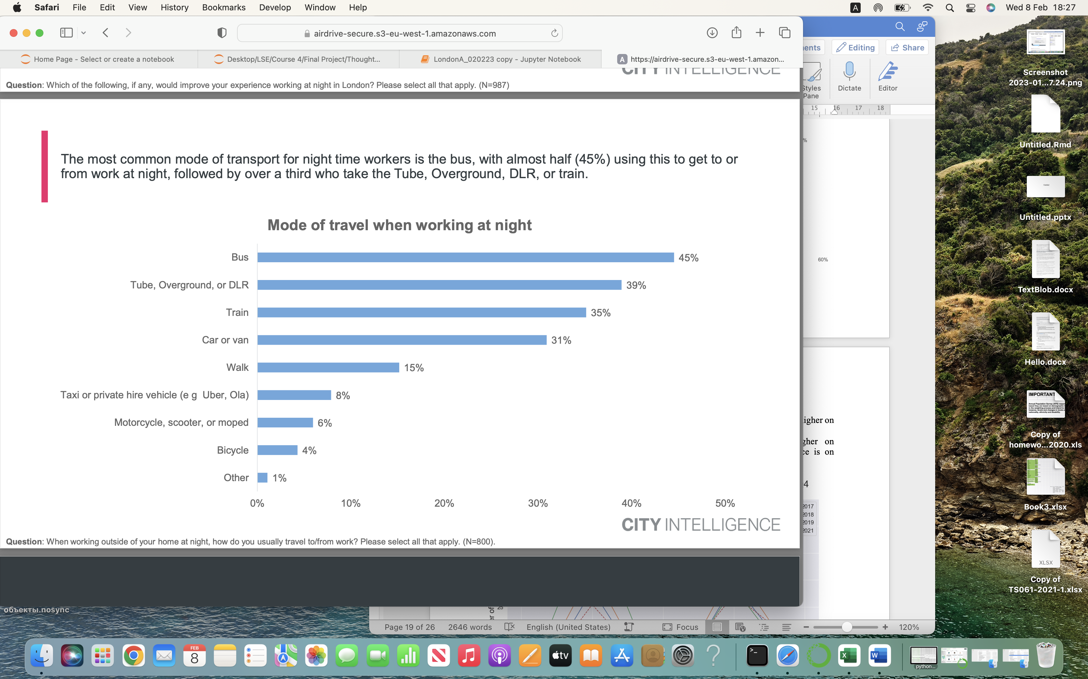

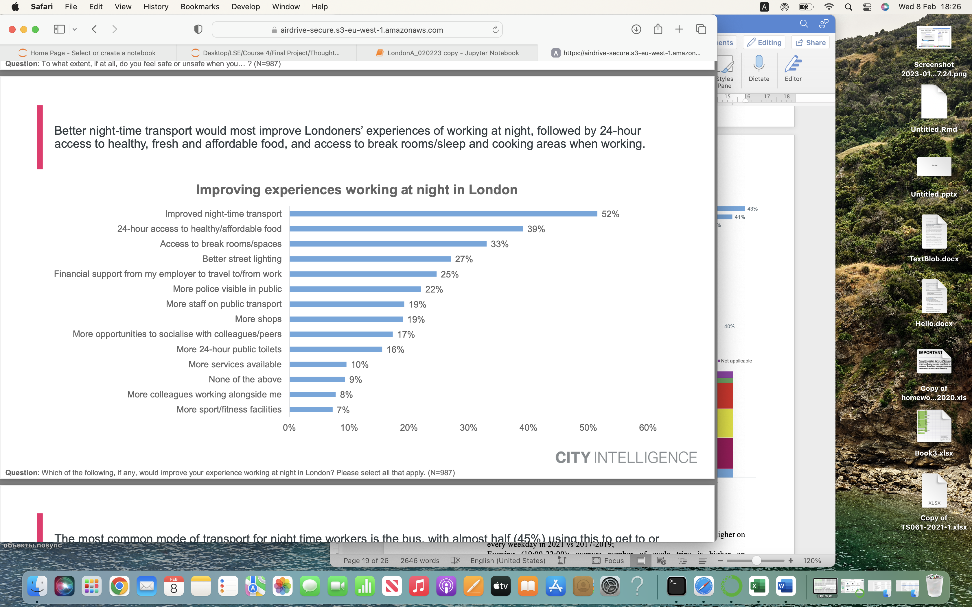

* Central London:
* Inter-peak (10:00-16:00): average number of cycle trips consistently higher on every weekday in 2021 vs 2017-2019;
* Evening (19:00-22:00): average number of cycle trips is higher on Wednesdays-Fridays in 2021 vs 2017-2019 (the biggest difference is on Wednesday):

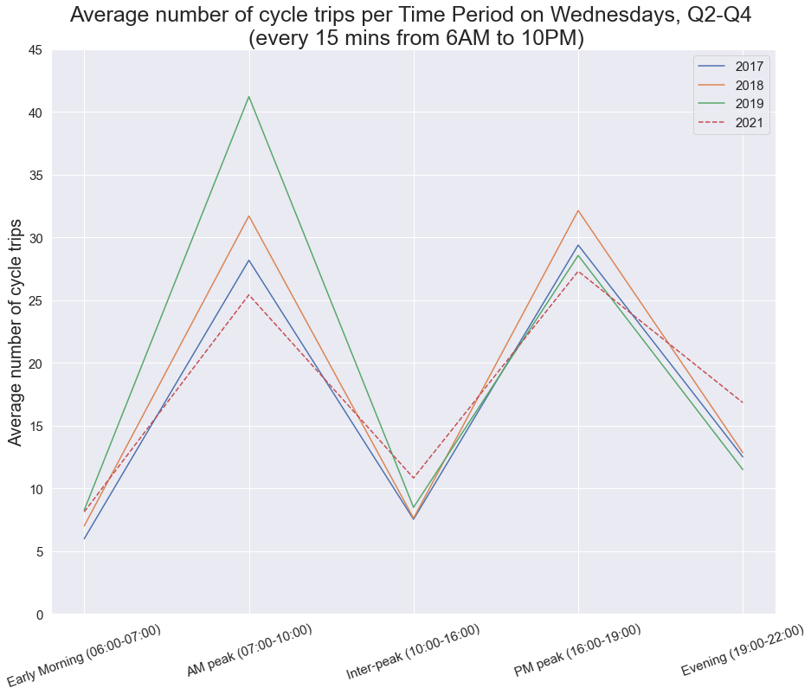

* Three most busiest boroughs by cycle traffic on Wednesday evening:

|  | **Borough** | **Avg No of cycle trips**  **(15 mins; 7-10PM)** |
| --- | --- | --- |
| 1 | Southwark | 24.65 |
| 2 | City of London | 20.94 |
| 3 | Islington | 20.51 |

* 20 most busiest streets by cycle traffic on Wednesday evening:

|  | **Location** | **Avg No of cycle trips (15 mins; 7-10PM)** |
| --- | --- | --- |
| 1 | New Bridge Street | 59.15 |
| 2 | Farringdon Street | 54.79 |
| 3 | Borough High Street | 51.06 |
| 4 | Green Park (cycle lane only) | 48.04 |
| 5 | Westminster Bridge | 45.83 |
| 6 | Bishopsgate | 45.05 |
| 7 | Theobald's Road | 42.62 |
| 8 | London Road | 42.25 |
| 9 | Oxford Street (west) | 39.67 |
| 10 | The Mall | 37.40 |
| 11 | Farringdon Road (near station) | 37.23 |
| 12 | Clerkenwell Road (east) | 36.85 |
| 13 | Blackfriars Road | 36.79 |
| 14 | Blackfriars Road (Southwark station) | 36.08 |
| 15 | Old Street | 35.29 |
| 16 | Birdcage Walk | 34.50 |
| 17 | Oxford Street (east) | 33.58 |
| 18 | Calthorpe Street | 31.50 |
| 19 | Whitehall (south of Horse Guards Avenue) | 28.50 |
| 20 | Piccadilly | 28.20 |

* Inner London:
* Inter-peak (10:00-16:00): average number of cycle trips consistently higher on every weekday in 2021 vs 2017-2019;
* Evening (19:00-22:00): average number of cycle trips is higher on Tuesdays and Thursdays-Fridays in 2021 vs 2017-2019 (the highest average number of cycle trips is on Thursday evening):

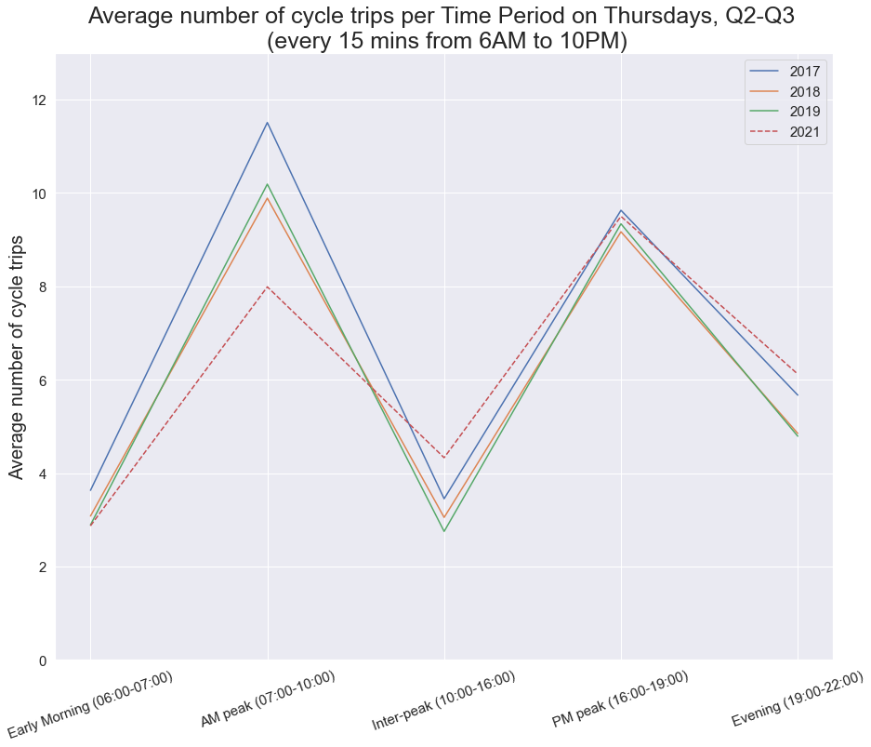

* Seven most busiest boroughs by cycle traffic on Thursday evening:

|  | **Borough** | **Avg No of cycle trips (15 mins; 7-10PM)** |
| --- | --- | --- |
| 1 | Islington | 8.42 |
| 2 | Hackney | 7.70 |
| 3 | Westminster | 7.45 |
| 4 | Southwark | 7.15 |
| 5 | Kensington & Chelsea | 6.56 |
| 6 | Hammersmith & Fulham | 6.16 |
| 7 | Camden | 6.15 |

* 20 most busiest streets by cycle traffic on Thursday evening:

|  | **Location** | **Avg No of cycle trips (15 mins; 7-10PM)** |
| --- | --- | --- |
| **1** | Kensington Road | 38.67 |
| **2** | Walworth Road | 30.38 |
| **3** | King's Road | 28.62 |
| **4** | New Kent Road | 24.21 |
| **5** | Upper Street | 24.04 |
| **6** | Barnsbury Road | 22.17 |
| **7** | Balls Pond Road | 21.00 |
| **8** | Lots Road | 18.29 |
| **9** | Mare Street | 17.08 |
| **10** | Burdett Road (south of Limehouse Cut) | 16.00 |
| **11** | Camden Road | 15.71 |
| **12** | Dalston Lane | 13.79 |
| **13** | Downs Road | 13.04 |
| **14** | Hammersmith Road | 12.80 |
| **15** | Old Kent Road | 12.42 |
| **16** | Old Brompton Road | 11.57 |
| **17** | Lowndes Street | 11.42 |
| **18** | Grove Road | 10.04 |
| **19** | Prince of Wales Road | 8.75 |
| **20** | Upper Clapton Road | 8.58 |

* Outer London:
* Inter-peak (10:00-16:00): apart from on Mondays, average number of cycle trips consistently higher on every weekday in 2021 vs 2017-2019;
* Evening (19:00-22:00): average number of cycle trips is higher on Tuesdays and Thursdays-Fridays in 2021 vs 2017-2019 (the biggest difference in average number of cycle trips between 2021 and 2017-2019 is on Thursday evening):

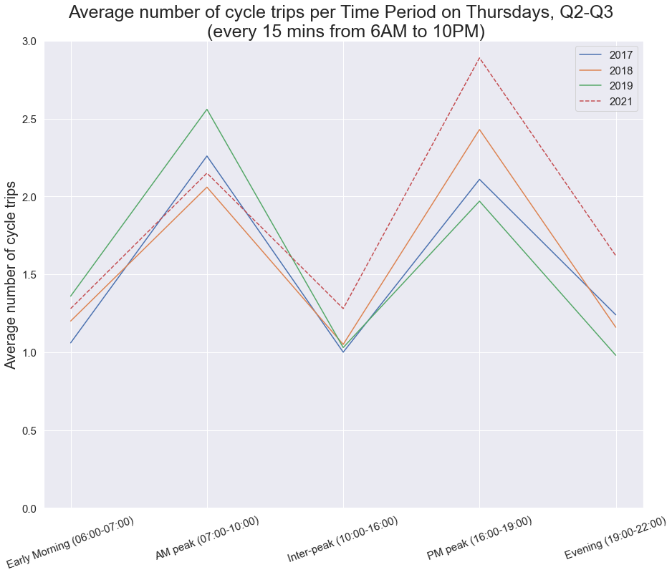

* Five most busiest boroughs by cycle traffic on Thursday evening:

|  | **Borough** | **Avg No of cycle trips (15 mins; 7-10PM)** |
| --- | --- | --- |
| 1 | Kingston upon Thames | 5.75 |
| 2 | Lewisham | 2.91 |
| 3 | Newham | 2.20 |
| 4 | Haringey | 2.02 |
| 5 | Merton | 1.98 |

* 10 most busiest streets by cycle traffic on Thursday evening:

|  | **Location** | **Avg No of cycle trips (15 mins; 7-10PM)** |
| --- | --- | --- |
| 1 | Kings Road | 8.46 |
| 2 | High Road | 6.97 |
| 3 | Greenway (Manor Road) | 6.96 |
| 4 | Duke Humphrey Road | 6.71 |
| 5 | Anerley Road | 5.58 |
| 6 | London Road | 5.17 |
| 7 | Bromley Road | 3.96 |
| 8 | Crane Street | 3.50 |
| 9 | Leytonstone Road | 3.42 |
| 10 | Orient Way | 3.12 |